Company Background

Zapdramatic was founded in July 2000 by filmmaker Michael Gibson and Negotiation and Alternative Dispute Resolution experts Allan Stitt, Frank Handy and Lisa Feld. Zap’s goal is to popularize the art and science of negotiation to a world audience using interactive simulated adventure games.

The first Zapdramatic game was launched in January 2001 when “The Desperate Dad”, the first of nine episodes in the Ambition murder mystery series, became an underground hit. The episode brought thousands of users to the Zapdramatic Web site, which has grown into a popular member-supported game environment.

Interestingly, over 50 per cent of Zap’s paying membership is female. This is a significant achievement in the online gaming world, which has traditionally catered to a younger, male demographic.

In January 2004, Zap released Episode 6 ("The Suspects") in the Ambition series to Newgrounds.com, the world’s largest flash portal. The episode earned a featured spot on the main page at Newgrounds and in three days had logged over 117,000 views with an average vote rating of 4/5.

A great deal of the appeal of Zapdramatic’s online negotiation games lies on the fact that creator and user can interact with ease. With each launch of a new Zapdramatic episode, users from around the world write in with comments and suggestions many of which are incorporated into subsequent episodes. This collaborative process has helped Zap create challenging, engaging, user-friendly experience for all ages.

Zap has also created licensed and customized online negotiation games for the corporate, professional and educational markets. In February 2003, it launched an eight-part university level online negotiation course. Four universities around the world currently offer certificates to users upon completion of the course.

This April, Zap launches its latest series, Move or Die, an interactive animated adventure, which challenges users to successfully negotiate with two ethically challenged siblings. Users from across Canada can log onto the Sympatico/MSN portal to play the first hair-raising episode. Subsequent episodes can be found on the Zapdramatic Web site at www.zapdramatic.com.

Move or Die was honored in September with the Vortex Prize at the inaugural McLuhan International Festival of the Future.

Zapdramatic is a division of the Stitt Feld Handy Group.

Stitt Feld Handy Group Background

The members of the Stitt Feld Handy Group teach, practice, conduct research, and publish in the field of Alternative Dispute Resolution (ADR) and Negotiation.

The Stitt Feld Handy Group has trained over 10,000 people in its workshops, currently conducted in North America, Europe, Asia, Africa, and Australia. The Group conducts workshops for the public in joint venture with various universities including the University of Windsor, the University of Notre Dame, The College of Law (UK), and La Trobe University (Australia). The Group also designs and conducts customized workshops for both the private and public sector.

The Stitt Feld Handy Group's ADR Workshops use an interactive approach, designed to provide people with ADR skills to resolve conflict effectively and efficiently, without damage to the relationship. The Group's Negotiation workshops focus on helping people become powerful negotiators. The Stitt Feld Handy Group also offers an online negotiation course for people who cannot attend the in-person course. In the online course, participants negotiate with animated computer characters that ask questions, make statements, and otherwise try to behave badly.

The Stitt Feld Handy Group, a Division of ADR Chambers, offers negotiation, mediation, and arbitration services for parties who wish to avoid recourse to traditional litigation. The firm provides negotiation advice to help clients negotiate more effectively; non-binding mediation services, assisting the parties to search for areas of agreement and helping them fashion a satisfactory resolution; arbitration services that provide parties with a binding decision; and coaching services to help individuals approach difficult situations more effectively.

The Stitt Feld Handy Group also provides consultation and advice to companies and other organizations for the design and implementation of conflict management systems.

Zapdramatic Partners

Michael Gibson


Michael Gibson is president of Zapdramatic, a subsidiary of Stitt Feld Handy Group. Zapdramatic produces interactive online games, one of the fastest growing segments of the global entertainment and media market. Michael is the lead writer, programmer and animator of the Web dramas and online negotiation course modules.

Prior to launching Zapdramatic, Michael worked as a writer and director in film and television. His credits include the feature length film, Defy Gravity, starring RH Thomson and Chapelle Jaffe. TV work includes the documentary series “My Canada Includes Quebec” and the multi-award-winning half-hour dramas, "The Bellringer", and "When Edgar Returns".

Michael studied architecture at Carleton University and was a resident of the TV drama program at the Canadian Film Centre, where he developed the half-hour comedy series, “Max Wrathburn”, about a community dispute resolution specialist and his dysfunctional family.

Michael has two feature film scripts in development, Love you Madly, and Irrational Numbers. The latter was nominated for the 2004 WGC Jim Burt Prize.

Zapdramatic Partners

Allan Stitt


Allan Stitt is the President of ADR Chambers and the Stitt Feld Handy Group. He is a Toronto-based mediator, arbitrator, negotiation consultant, facilitator, trainer, and Alternative Dispute Resolution (ADR) systems design specialist. He is an Adjunct Professor at the University of Toronto Law School and a Special Lecturer at the University of Windsor Faculty of Law, teaching courses in Negotiation and Alternative Dispute Resolution. He has also been a Lecturer at the University of Notre Dame, the University of Lisbon (Portugal), and the University of the Philippines and has taught ADR and Negotiation courses throughout North America, Europe, Asia, Africa and Australia.

After earning his B.Comm at the University of Toronto, Allan earned his LL.B. at the University of Windsor Faculty of Law and his J.D. at the University of Detroit Law School, graduating first in his class in both law schools. He then earned his LL.M. degree at Harvard Law School. Until 1994, he was a litigator at Osler, Hoskin & Harcourt.
While at Harvard Law School, Allan studied negotiation and ADR with Professor Roger Fisher, Professor Frank Sander, and Bruce Patton. He has returned to Harvard on a number of occasions to act as a Teaching Assistant to Professor Fisher. Allan is the Past President of the ADR Institute of Canada, the Arbitration and Mediation Institute of Canada, and the Arbitration and Mediation Institute of Ontario. He is the current Chair of the Sport Dispute Resolution Centre of Canada. He has designed ADR systems for such organizations as the Canadian Bankers Association, the Ontario Human Rights Commission, the Law Society of Upper Canada, and Canadian Tire Corporation.

Allan is both a Chartered Mediator (C.Med.) and a Chartered Arbitrator (C.Arb.). He has mediated two-party and multi-party disputes in numerous contexts, including commercial, employment, corporate governance, workplace, banking, personal injury, sports, and breach of contract. He is a Roster Mediator, Ontario Mandatory Mediation Program - Toronto. He has also arbitrated numerous commercial cases including cases for the National Transportation Agency and the Ontario Farm Products Marketing Board. His books on ADR systems design, ADR For Organizations (1998), and Mediating Commercial Disputes (2003), were both business books bestsellers. His newest book is Mediation: A Practical Guide (2004) and he is the editor of the CCH ADR Practice Manual.

Zapdramatic Partners

Frank Handy


Frank Handy is Vice-President of ADR Chambers and the Stitt Feld Handy Group. He is a Toronto-based mediator, arbitrator, negotiation consultant, facilitator, trainer, and litigator. He lectures in courses in Negotiation and Alternative Dispute Resolution (ADR) at the University of Toronto Law School and University of Windsor Law School, and has taught Negotiation at Osgoode Hall Law School.

Frank received his LL.B. in 1988 from the University of Windsor Faculty of Law and then earned his LL.M. in ADR from Osgoode Hall Law School in 1998. Since completing his law degree, he has participated in several continuing education courses and seminars, including the Advanced Negotiation Course at the Program of Instruction for Lawyers conducted by Harvard University Law School. Prior to joining the Stitt Feld Handy Group, he practiced litigation at the law firm of Osler, Hoskin & Harcourt.

Frank has acted as a lawyer in administrative hearings, regulatory offenses and arbitration matters. Frank has participated in multi-party negotiations for individual, corporate, and government clients involving issues related to development proposals, government approvals, long term resource management planning, urban and rural development, park and recreation resources, municipal services restructuring, farm product regulatory and pricing systems, and other substance. Frank has adjudication experience through his practice and was a former Chairperson of the Employment Insurance Board of Referees.

Frank is a Chartered Mediator (C.Med.) and has mediated in a wide variety of litigation and non-litigation disputes. He has experience in regulatory matters such as Environmental, Municipal, Land Use Planning and Development, regulated farm products and rural affairs, as well as more general commercial, employment, workplace, grievance and general litigation. He is a Roster Mediator, Ontario Mandatory Mediation Program - Toronto.

Zapdramatic Fact Sheet

- Zap was founded July 2000 by filmmaker Michael Gibson and negotiation experts Allan Stitt and Frank Handy.

- Zapdramatic produces animated interactive simulations for the entertainment, educational and corporate markets.

- The most popular game on the Zapdramatic Web site is The Lusty Barfly with over 4 million views.

- The most annoying character as voted by Zapdramatic users in the Customer Service rep in The Negotiator series.

- Zapdramatic games require intelligence and human relations skills and are unlike the typical shoot’em up games that you find on the Internet.

- Zap dramas appeal to both men and women. Over 50 percent of Zapdramatic’s paying membership is made up of women.

- If Gary Bettman, Commissioner of the National Hockey League, and Bob Goodenow, Executive Director of the NHL Players' Association had played “Pavlov’s Hotel” (Module 5 of the University Certificate On-line Negotiation Course) they would have learned how competitive bargaining is an out of date technique that too often leads to angry losers on both sides.

- If Conrad Black and Martha Stewart had played Zap’s professionalism and ethics simulation they would have learned how casual self-serving remarks can slowly compound over time and lead to disproportionate consequences.

Zapdramatic Content Highlights

Zapdramatic’s intelligent and entertaining product line includes:

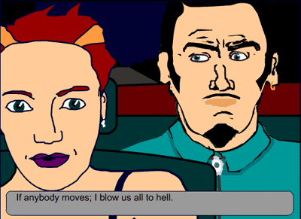 | Ambition is a 10-part episodic murder mystery game that has been drawing loyal fans since it launched in 2001. The series stars “Ted”, a desperate dad who straps dynamite to his waist in an effort to find his kids and ends up a suspect in a murder.
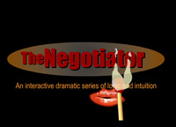 | The Negotiator series features three challenging negotiation situations: the first with a homeless man who wants money; the second with an infuriatingly cheerful customer service clerk; and the third with a boss who doesn’t want to give you a raise.
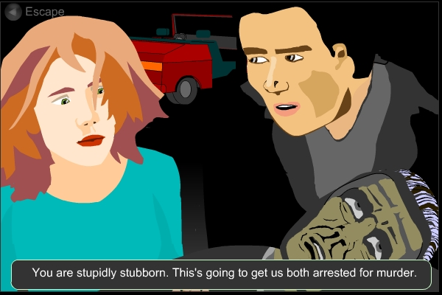 | Move or Die is a high-action animated interactive adventure game, featuring two ethically challenged siblings who present challenging arguments when asked to follow your good advice.
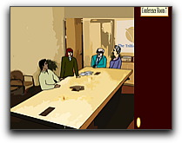 | The Mediator series places you in the challenging role of mediator in a sports dispute and in a neighborhood dispute.
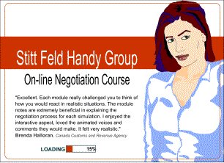 | Zap’s university-level online negotiation course consists of eight challenging simulated negotiations with animated computer characters. In just 6 hours you will become a more effective negotiator. Four universities now offer certificates for completion of the course.

###

For additional information or interviews, contact:
Julie Giles, Green Hat Communications
Tel: 416-762-5328/ E-mail: julie@green-hat.ca

